August 2023
Dear Friends

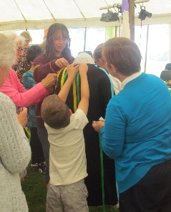
Welcome to August’s letter; again, filled with news and future events.

The team tasked with the necessary planning, thinking and ‘paperwork’, with the diocese, to prepare the ground for advertising and interviewing for our Rector and Pioneer Priest, have been working hard and against tight deadlines and we thank them for the work achieved so far. We hope to be able to give a full picture of the current situation next month; meantime, please keep this process in your prayers.

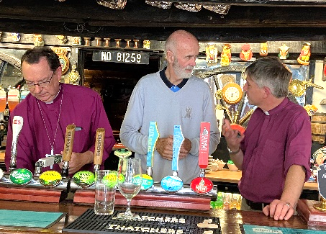
Church and Pub - two key places in the Community… On July 1st, Bishop Philip [Truro] and Bishop Hugh [St Germans] spent an afternoon in St Teath church hall, sharing details of the diocesan and deanery plans and chatting with members of the deanery. They visited the church and were impressed to see some of the children’s team work, along with the beautiful way the church and grounds are kept, before popping over to the pub! Pictured are +Philip pulling a pint and Barry having a good chat with +Hugh; a scene of real team work. Barry was quite impressed with +Philip’s bar skills; we don’t know if he offered him a job!!
In recent news, Bishop Philip is to leave his post as Bishop of Truro in the autumn; he will become the Bishop of Winchester; we thank him for his work here over recent years and wish him God’s blessing.
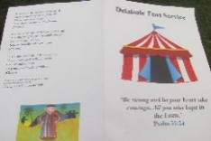
Boasting, jealousy, cruelty - the beginning of Delabole’s Carnival Service, sounding more like a soap opera than an act of worship! Church groups worked

together to help us all think about Joseph and his dysfunctional family. ‘Open the Book’ presented the story interspersed with familiar songs, old and new, with adults and children alike joining in the actions. We prayed with coloured ribbons! Long ones pinned to a tunic as we offered prayers for people and situations in need; and short ones to keep, reminding us to also pray for ourselves. As for Joseph and his family, they discovered how to listen to God, to forgive others and the power of reconciliation. God showed us all this; and the yumminess of doughnuts! [SW]

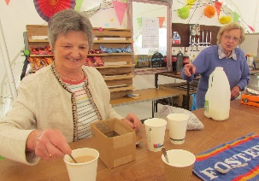
After a delicious bacon / vege bap and hot drinks, the Bible personality considered at St Teath’s Breakfast Church in the Carnival Tent, with the theme, ‘Listening to God’, was Gideon; we heard about him with a story during which we had to both listen out for words requiring congregation participation with an action or sound, and a Bible bingo. We pondered, ‘What the Bishop said’ [a story], ‘Listening vs Hearing’, ‘Receiving from God’ and a few folk shared their own experiences of hearing from God. We are grateful to the Carnival Committee for inviting the church to open the Carnival with a service in the marquee.

On 23rd July, Delabole received an unexpected visit by seventeen, very wet Belgium Scouts who camped overnight in St John’s, sleeping safely out of the rain and drying out some of their clothing. Nine visited Tricia and Nigel for showers, hot drinks and chocolate wafers. They were most grateful for the assistance.

We have shared together in several very joyful Songs of Praise and Cake, 4pm on the first Sunday of the month at St Thomas. As the summer months are always busy with holidays, visitors and harvest, we have paused these services for the summer and will resume in the Autumn.

Congratulations to Kieran and Ashleigh in their marriage at St Julitta’s on 8th July; we wish them many happy years together; with three motorbikes parked at the church door and the groom pulling wheelies after the service, they were off to a great start!

We welcomed Skylar in her baptism at St Teath on 16th July; a very joyful service - Skylar was most intrigued by Jeffrey’s beard during her time at the font; she pulled and pulled to see if it is real.

In sad news, we have marked the death and celebrated the life of Mrs Wendy Doige [Delabole] and Mr Glynn Lewtas [Delabole]. We keep their families and friends in our prayers.

We look forward; events this month include…

St Teath Children’s Team will be offering four events in the summer, in St Teath Church, Thursday afternoons, 2pm; free; all welcome; refreshments provided [for children and adults]:
3rd August; ‘The Beach’
10th August; ‘Den building’
17th August; ‘Boats & Explorers’
24th August; ‘Under the Sea’
We are grateful to our Children’s Team for putting this together. [GS]

Our joyous Afternoon Teas are in full swing at St Julitta’s. Do join us for a proper cream tea with home-made splits and cakes, every Thursday in August; 3pm - 4.30pm; our local and visitor customers range in age from a toddler to a 102-year-old. We first met Jessie from Trevone at a 4C's at St Thomas's. Her niece then brought her to St Julitta's accompanied by friends from St Merryn and St Eval! [MP]
St Thomas’ ‘Tea & Chat’ 1st and 15th August; 3pm - 4.30, all welcome.

St Thomas’ Coffee Morning 19th August; 10.30- 12 noon

August’s Services

Morning prayer is said at 9am each Wednesday at St Adwena and Friday at Lanteglos

Compline is said at 7pm at St Adwena each Friday and the second Thursday at St Julitta

Friday 4th 8.30am - St Julitta – Breakfast Communion

Sunday 6th 9.30am - CW Holy Communion; St Thomas
11am - Celebration Holy Communion; St Teath

Sunday 13th 9.30am - Morning Worship at St John’s
11am – Morning Worship; St Teath
11.15am - Holy Communion [BCP]; St Adwena

Sunday 20th 9.30am - Family Holy Communion; St Thomas
11am - Family Holy Communion; St Teath

Sunday 27th 9.30am - Holy Communion; St John’s
10am – Breakfast Church; St Teath
11.15am - Holy Communion [BCP] St Julitta

Thurs 31st 7pm - the monthly quiet, candlelit healing service at St. Thomas’ church, Camelford; including Holy Communion, prayer and anointing. All are welcome. Please do come along and bring others
Jesus said, “come unto me all who are weary and burdened and I will give you rest.” Matthew 11:28.

S-T-O-P P-R-E-S-S
Congratulations to St Teath Choir, for their second place in St Teath Carnival, as they ‘Sang for joy as Sister Act’. ‘O Happy Day’!

We are here to assist; so please keep these contacts handy…

St Adwena, Advent
William Gore thegores@hotmail.co.uk 01840 212800
Kerstin Lewis kerstinlewis@hotmail.com 01840 211161

St John’s, Delabole
Tricia Hicks nigelhicks56@yahoo.co.uk 01840 212520
Lesley George george1359@btinternet.com 01840 770462

St Julitta, Lanteglos & St Thomas, Camelford
Mary Pearce maryboglepearce@gmail.com 01840 212665

St Teath
Gareth Stubberfield stubbery2@hotmail.co.uk 07498 580454
Dave Winter david_winter@sky.com 07976 854117

Rev Jeffrey Terry stpiran@icloud.com 07562 700170

Rev Geraldine Ashton parishnurse@bodminway.org 07467 203116

Claire Salzmann salzmannclaire@gmail.com 01840 212713

With best wishes to all, for a refreshing and enjoyable summer,
Claire

